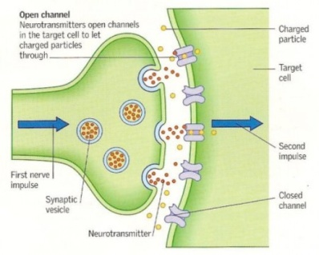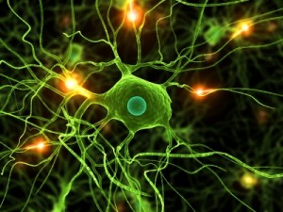

**Findings:**

**Conclusions:**

**Evaluate this experiment:**

**(State, describe and Explain 1 x positive and 1 x negative evaluation of this research)**

**IB Psychology BLoA Study Summary Sheet**

**Study title and author:**

**BLoA principle that this illustrates?**

**Research method used:**

**Procedure:**

**MRI scanning:**

**Aim:**